Kent Mark

CPRE 185 – Homework 2

1/28/18

1. Which of the following is (are) reserved keywords in C language?
2. myInt
3. int int is a reserved keyword for C language
4. Int
5. INT
6. Which of the following is (are) *invalid variable names* in C language? Why?
7. _hello
8. 5hello – variable cannot start with digit
9. hello5
10. he5llo

*/**********************************************/*

*/*** CPRE 185 – Homework 2 ***/*

*/**********************************************/*

*/*** Author – Kent Mark ****/*

*/*** Lab section – ‘B’ ****/*

*/*** Date started – 1/28/18 ****/*

*/*** Comments – The code works but after you run it move the cursor up and hit "ENTER" again to print conversion *****/*

*/**************************************************/*

*#include <stdio.h> /* Fixed to correct library, was previously misspelled */*

*#include <math.h> /* Added math library to perform computations */*

*int main(void) /* Removed invalid definition "voids", replaced with void */*

*{*

*int kmToMile; /* Replaced double with int data type and unassigned a value to variable*/*

*printf("Enter the number of kilometers: ");*

*scanf("%d\n",&kmToMile); /* Changed %lf to %d since the argument is an integer */*

*printf("This is equivalent to %.2f miles\n", kmToMile*0.6213); /* Deleted two newlines, added terminal statement, multipled variable by 0.6213 */*

*return 0; /* Added return statement */*

*}*

1. 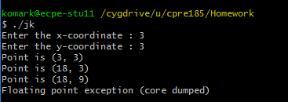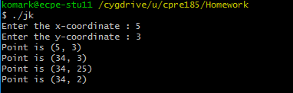The output doesn’t match the numbers I got by hand because the variables for the X coordinate and the Y coordinate are continuously plugged into subsequent operations, also the order of operations is ignored. For example in program 1 the 34 for the X coordinate is plugged into the formula to determine the Y coordinate and due to the fact the problem is executed left to right the answer become 3 for the Y-coordinate. Strangely though for program 2 the answers for line 2 and line 3 are flipped. In addition the “Floating point exception (core dumped)” showed up because the last operation had no mathematical value, when the numbers were plugged in it resulted in “18/0”.